Project Design Phase
Proposed solution
Date | 01-10-2025
Team ID | NM2025TMID07589
Project Name | Educational Organization using ServiceNow
Maximum Marks | 4 Marks

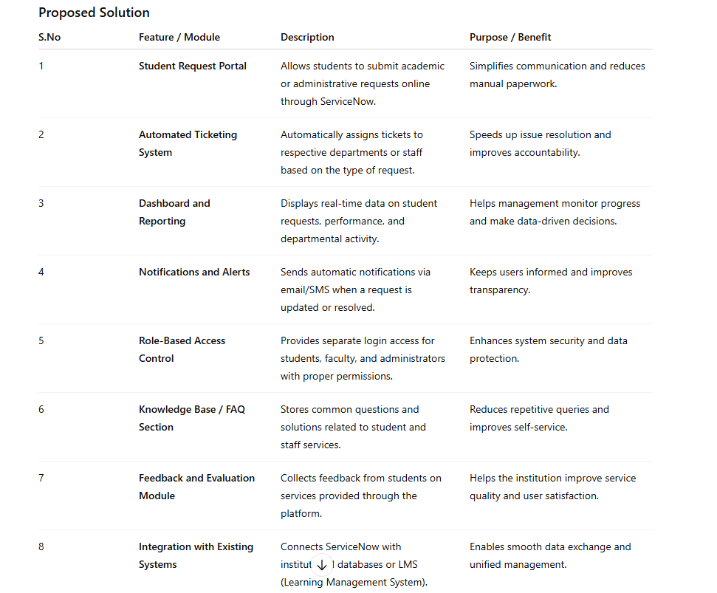

Solution Description:
The project “Educational Organization Using ServiceNow” successfully demonstrates how digital transformation can simplify and enhance the management of academic and administrative processes in educational institutions. By implementing ServiceNow, the project provides an efficient platform that automates workflows, improves communication between departments, and ensures transparency in handling student requests and services.
The proposed system not only reduces manual workload and processing time but also strengthens coordination among staff, students, and administrators. Features such as the student request portal, automated ticketing, dashboards, and notifications contribute to faster problem resolution and improved decision-making.
Overall, this project emphasizes the importance of adopting ServiceNow as a centralized solution for educational organizations, leading to improved efficiency, accountability, and satisfaction for all users. It aligns with the modern vision of creating a smart, digital, and service-oriented educational environment that meets the growing needs of students and institutions alike.

